Lesson 04 Lesson-End Project

Create a Virtual Machine Scale Set (VMSS) with Autoscale using ARM Templates

Project Agenda: To create a virtual machine scale set with autoscale using ARM templates

Description: You are given the task of creating a virtual machine scale set. Instead of performing this task manually, use ARM templates.

Tools Required: Azure account with administrator access

Prerequisites: None

Expected Deliverables: Add a screenshot showing the scale set created along with the ARM template file

Steps to be followed:
- Create a VM scale set running an IIS server using an ARM template
- Monitor the VMSS

Step 1: Create a VM scale set running an IIS server using an ARM template

- Navigate to this link: https://github.com/Azure/azure-quickstart-templates/tree/master/quickstarts/microsoft.compute/vmss-windows-autoscale

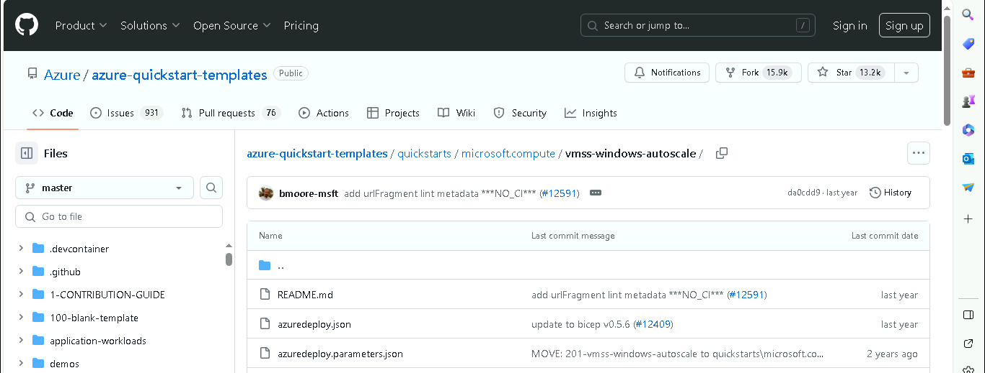

- Scroll and click on Deploy to Azure

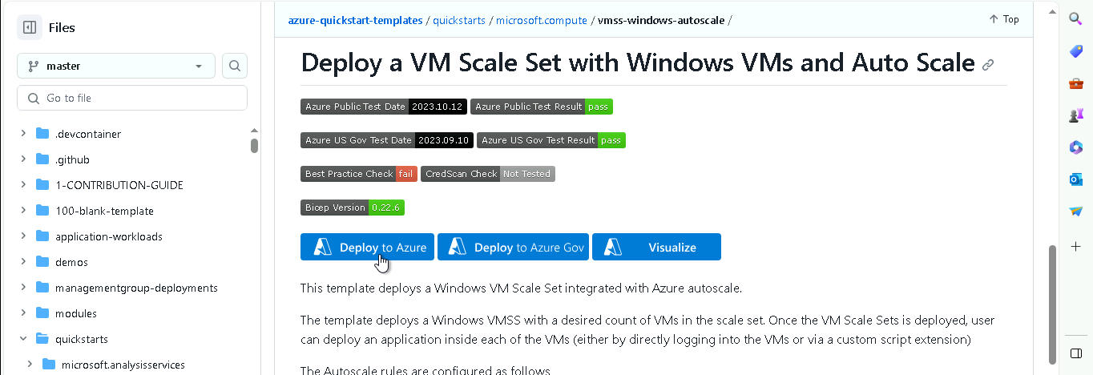

- Sign in with the required credentials

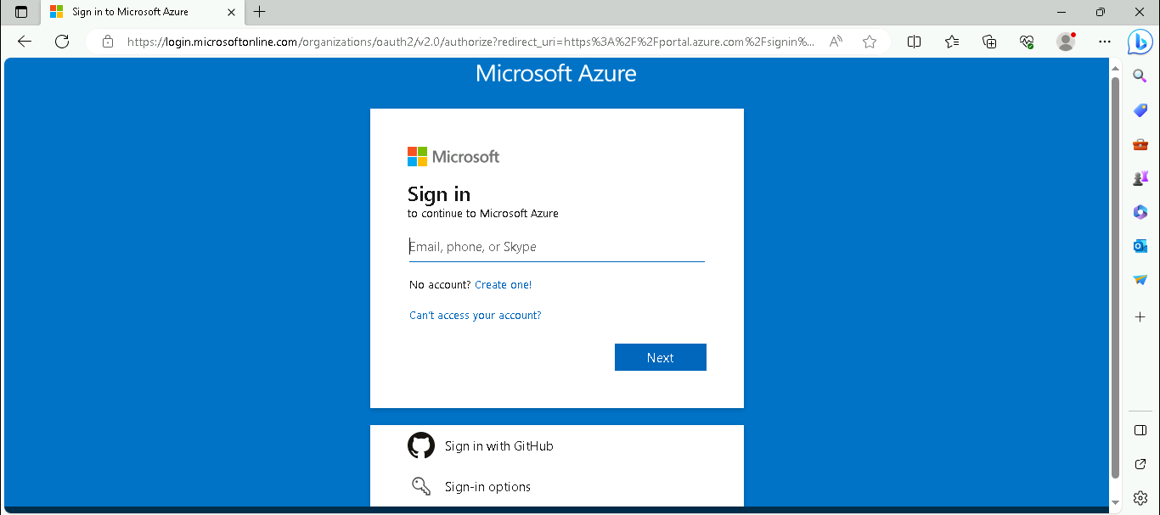

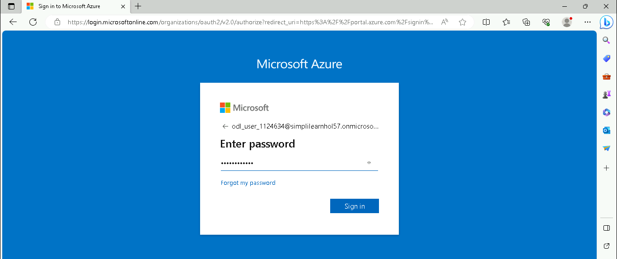

- In the Deploy a VM Scale Set with Windows VMs and Auto Scale page, click on Edit template

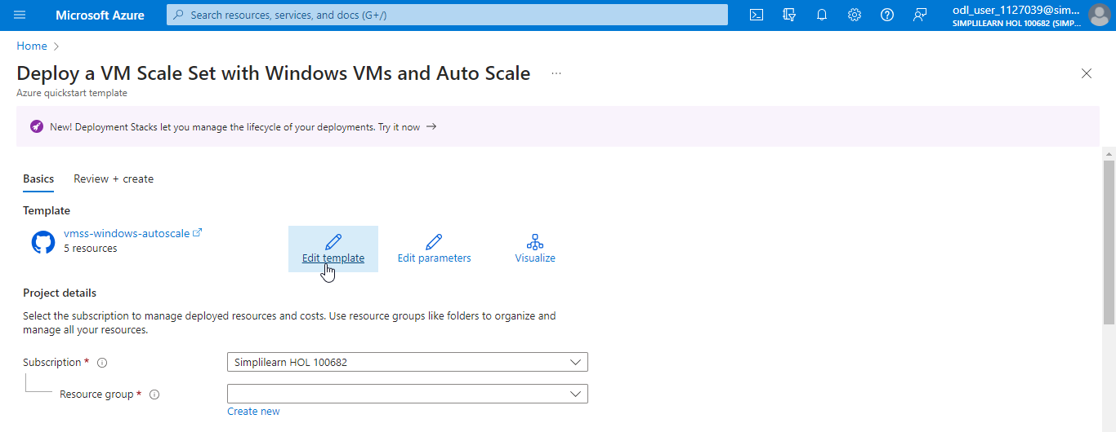

- In the Edit template page, navigate to [variables(‘loadBalancerName’)](Microsoft.Network/loadBalancers) under Resources (5)

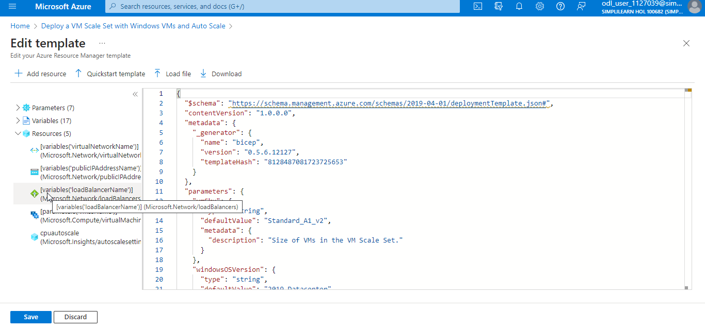

- Add the following code after “properties” and before “dependsOn”:
“sku”: {
“name”: “Basic”
},

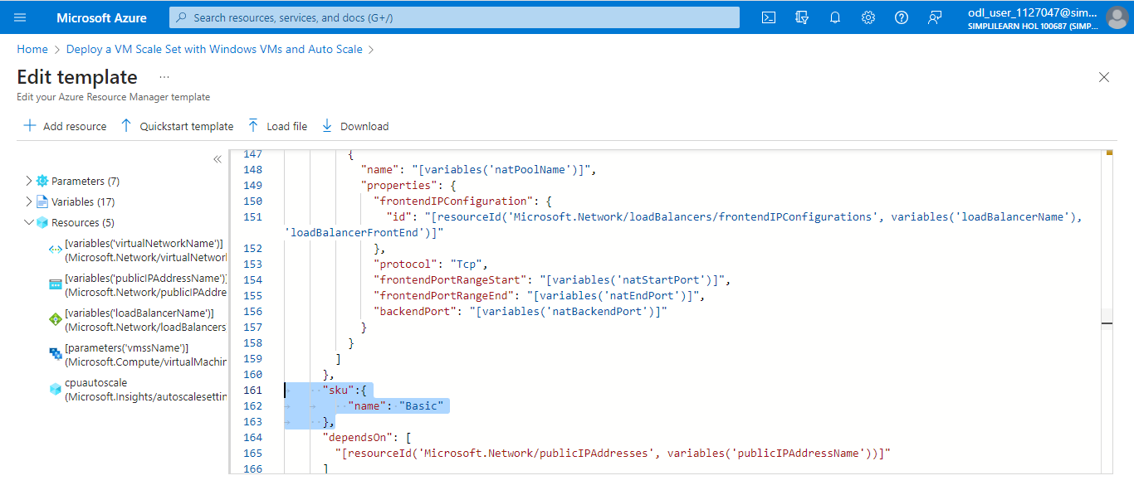

- Click Save

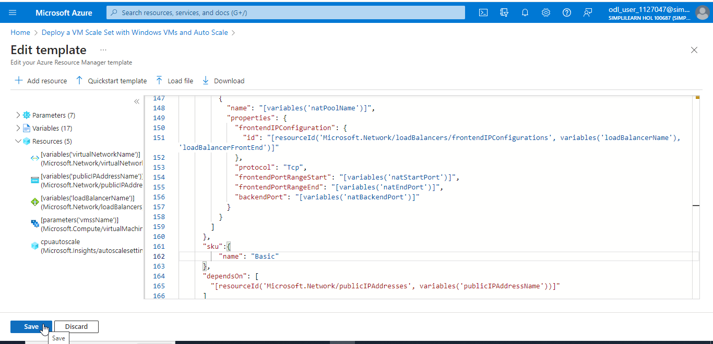

- Under Project Details on the Custom deployment page, click on Create new to create a new Resource group

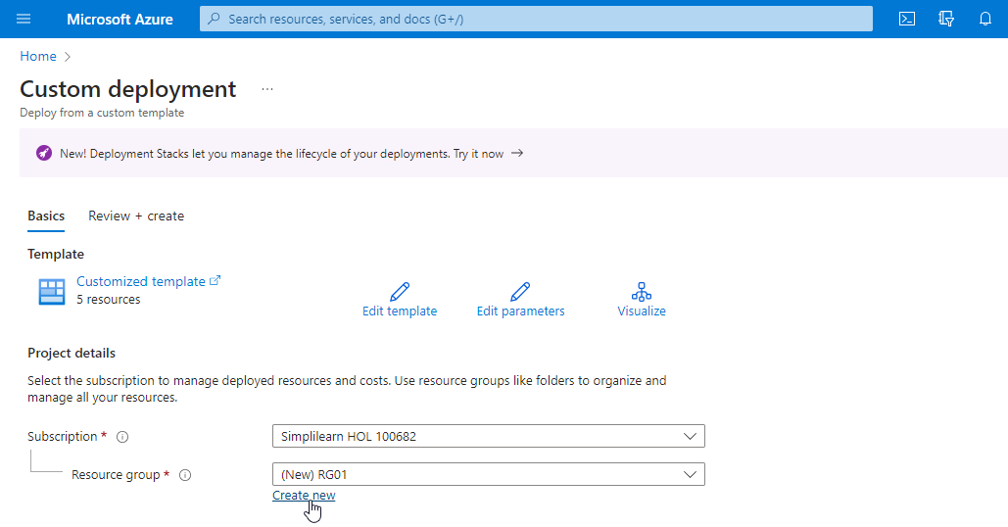

- Under Instance details, provide the details as shown in the below screenshot:

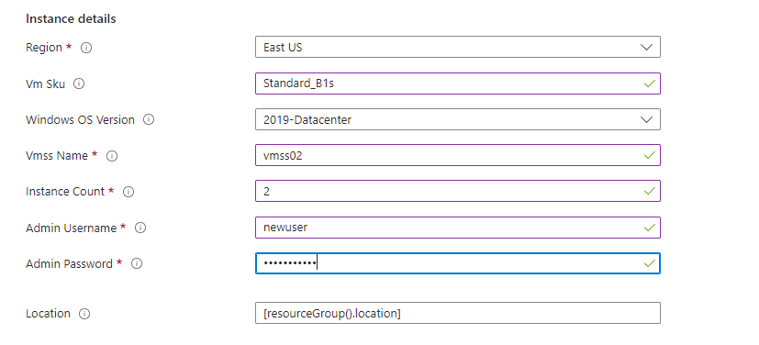

- Click on Review + create

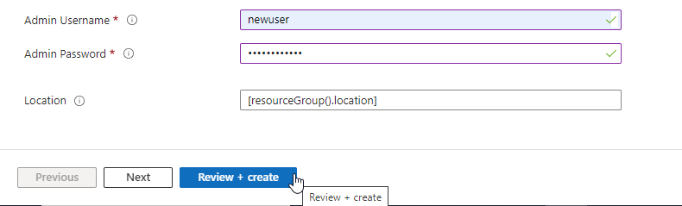

- Click on Create

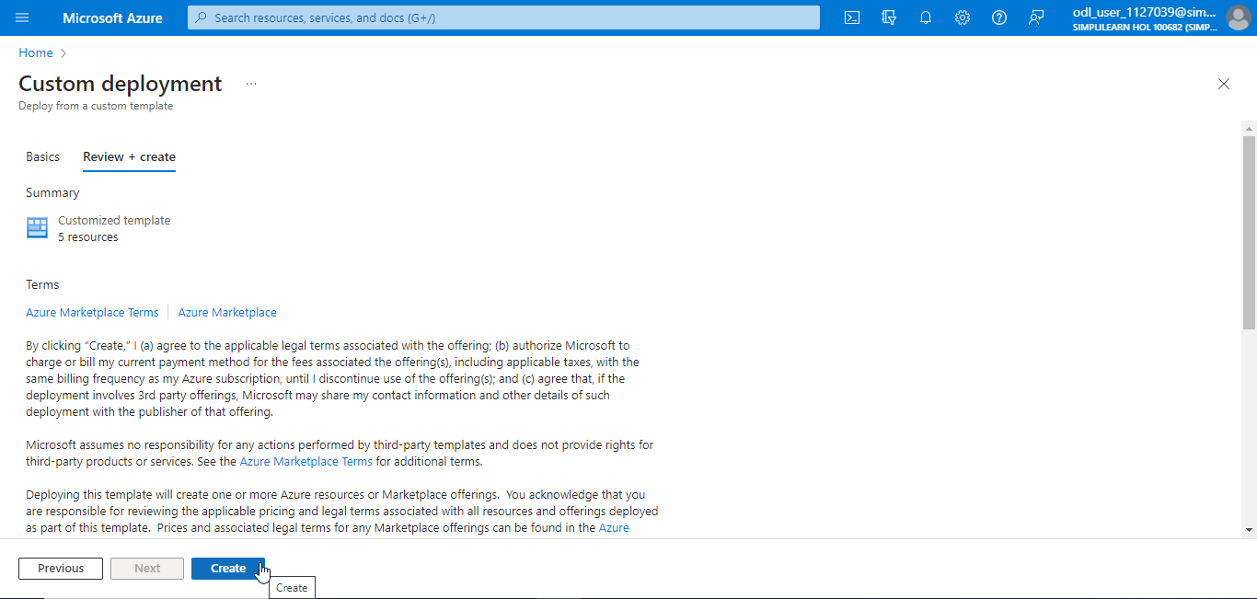

The VMSS was created successfully, as shown in the below screenshot:

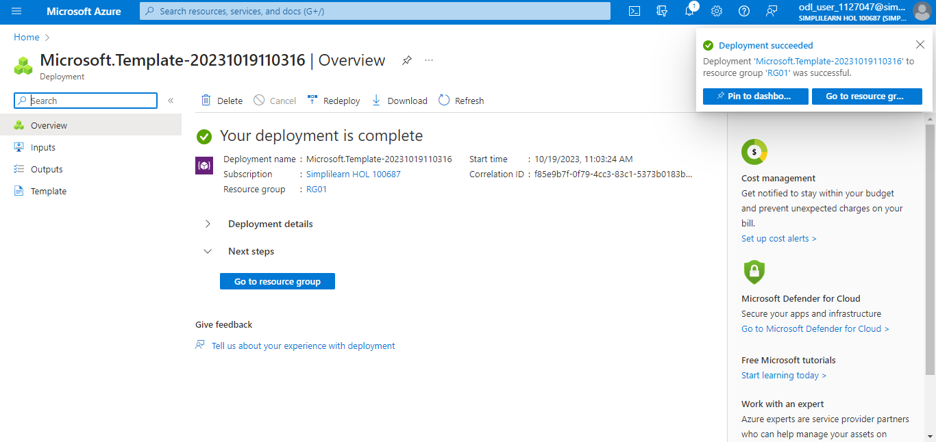

Step 2: Monitor the VMSS

  - Search for and select Virtual machine scale sets

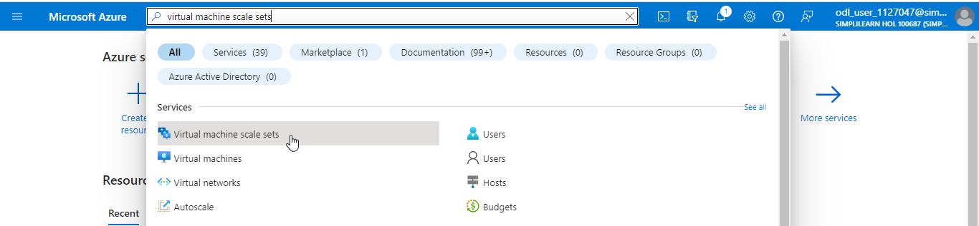

  - In the Virtual machine scale sets page, click on the created VMSS (vmss02)

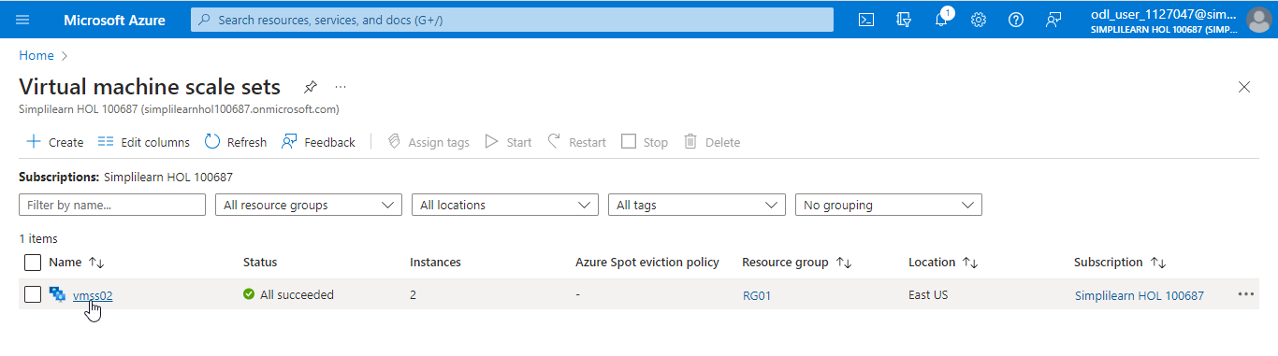

  - Click on Instances under Settings

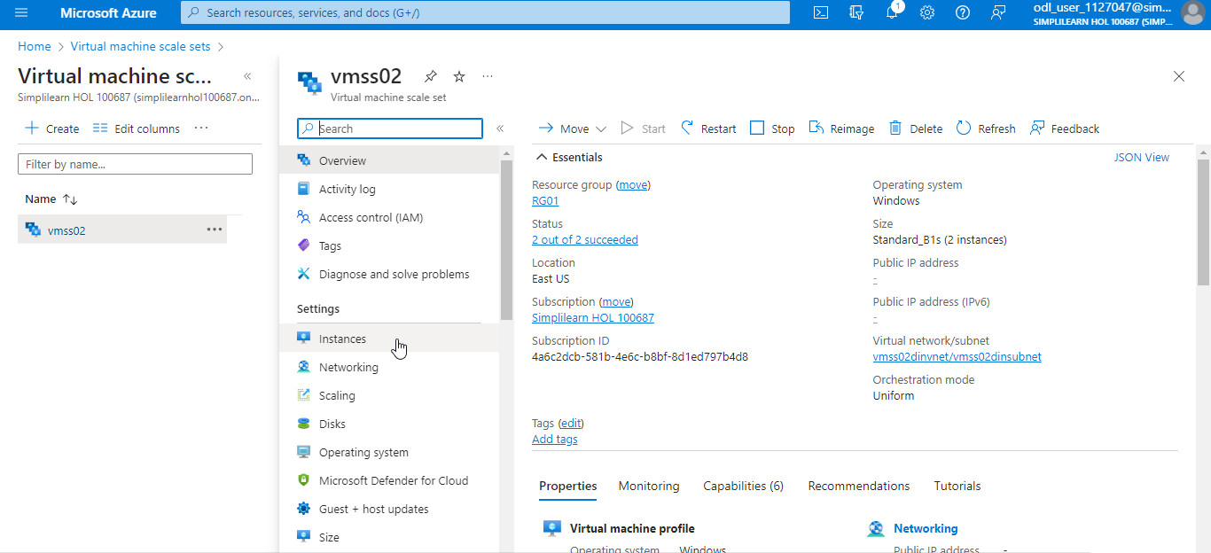

On the Instances page, you will be able to view all the instances, as shown in the screenshot below:

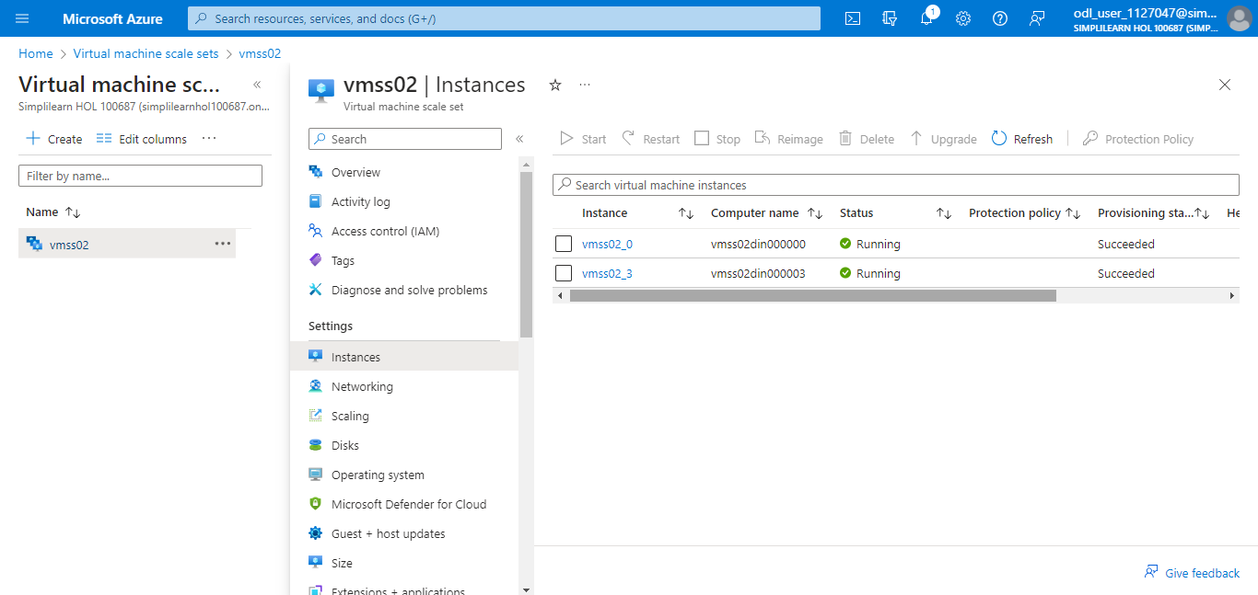

  - Click on Scaling under Settings

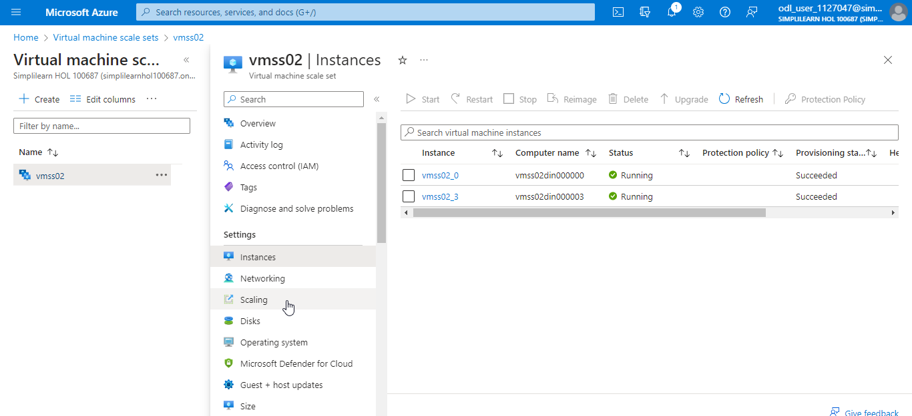

  - In the Scaling page, navigate to the Configure tab

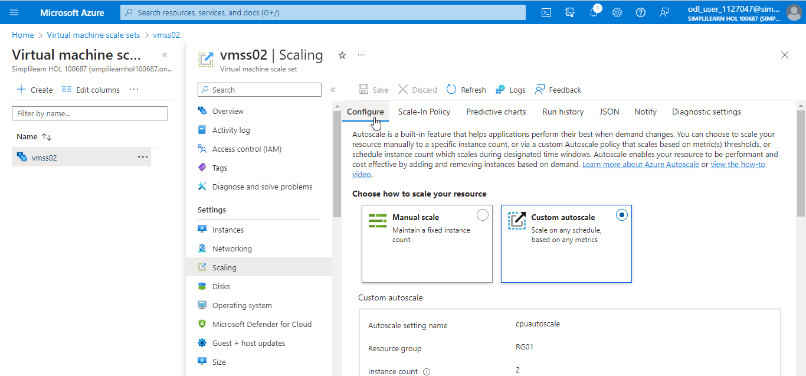

  - Under the Default tab, locate Scale out and Scale in to identify the instance count

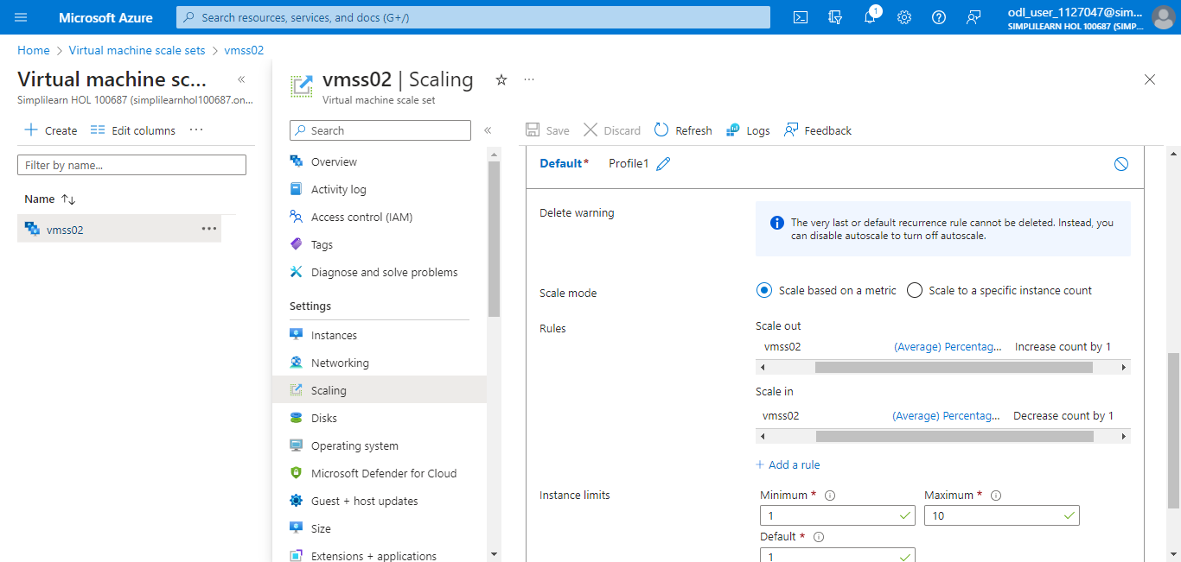

You have successfully created VMSS with autoscale using ARM templates.

